A Newly Characterized Streptomyces sp. is of High Potential Value in Converting Organic Wastes into Value-added Bioproducts

Sarita Shrestha¹, Wensheng Qin¹
¹Department of Biology, Lakehead University, Thunder Bay, Ontario, P7B 5E1
*Corresponding author: wqin@lakeheadu.ca
Abstract
Background/Objectives: The increase in population has a direct or indirect relation with increase in agro-waste. These waste if not managed properly, there may be various subsequences which may further develop health issues. However, those biomasses can be utilized as resources for enzymes, bioactive compounds, pectin production, and substrate for the growth of microorganisms as they are renewable and inexpensive natural resource. In addition, natural resource utilization help solving the energy shortage problem, pollution concerns, and waste disposal issues.
Method: In this study, forest soil was collected, and the pectinolytic bacteria were screened by flooding potassium iodide over the colonies. Further, the pectinolytic bacteria were identified based on morphological and microscopical characteristics, different biochemical tests, and 16s rDNA sequencing. Different biomasses were used as substrate for enzymes production, for bioactive compound screening and studied their degradation. In addition, total phenolic content and flavonoids of different biomasses were analyzed.
Results: A bacterial isolate was identified as Streptomyces sp. and it was used for pectinase production using different agro-waste. Among biomasses, pomegranate peel illustrated as the best substrate for pectinase production.
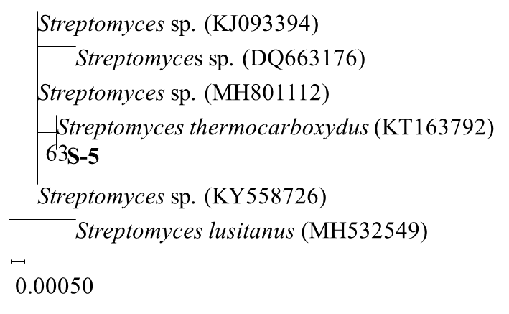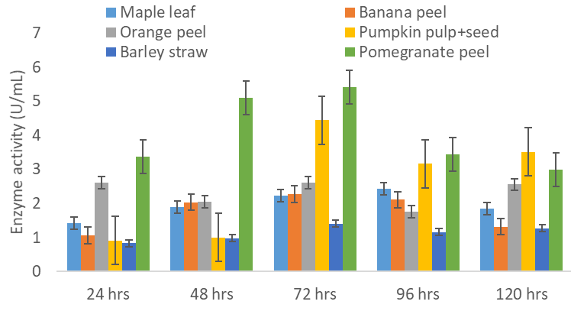
Fig.1 Phylogenetic relationship

Fig.2 Pectinase activity from different biomasses

Conclusions: Streptomyces sp., one of the isolated pectinolytic bacteria from forest soil, was used for pectinase production using different agro-waste. Among biomasses, pomegranate peel illustrated as the best substrate for pectinase production. Simple pretreatment like washing biomasses with warm water might decrease the production cost. However, further details such as different optimization conditions for maximum production of different value-added products and characterization of enzymes for industrial applications should be explored.
Keywords: pectinase, agrowaste/biomass, Streptomyces sp., degradation

