Effects of nZVI modified biochar and earthworms on the dissipation of sulfamethoxazole, microbial antibiotic resistance genes and microbial community structures in soil

Yuen Zhu¹, Yuanyuan Li¹, Jiarui Miao¹, Guixiang Zhang², Hua Li¹

¹ Shanxi University, Shanxi, China
²Taiyuan University of Science and Technology, Shanxi, China

BACKGROUND/OBJECTIVES: Sulfamethoxazole (SMX) potentially enters soils due to its higher water solubility, low chelating ability, and low binding constants. The effects of biochar on soil microbial communities are quite significant for contaminant dissipation in soil. Earthworm modifies the composition and activity of soil microorganisms and enhances the dissipation of contaminants in soil.

METHOD: Established soil incubation experiments to evaluate the effect of nZVI modified biochar and its interaction with earthworm on the dissipation of SMX, corresponding microbial antibiotic resistance genes (ARGs), as well as microbial community structures.

RESULTS: The addition of earthworm in the SMX-contaminated soil significantly reduced the abundance of SMX by 50.93%-78.36% in soils, it reached to 81.66% in nZVI modified biochar treated soils. The addition of earthworm significantly increased the expression of the ARGs such as the intI1 gene in soil. The nZVI modified biochar significantly reduced the expression of the ARGs and the abundance of earthworm in soil.
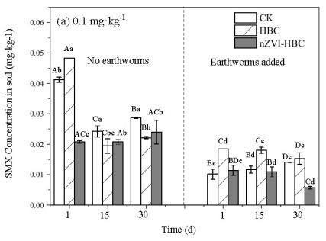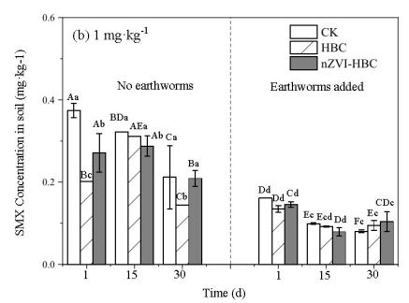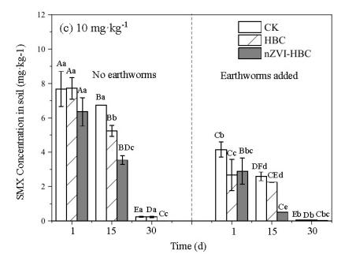
Fig.1 The effects of nZVI modified biochar and earthworm on the concentrations of SMX in soil.

CONCLUSION/IMPLICATION: The nZVI modified biochar and earthworm could separately or interactively accelerate the SMX dissipation in soil. Treatment of soil with nZVI modified biochar and earthworm enriched microbial community associated with SMX degradation in soil.

