Developing a Descriptive Chatbot for Mental Health Awareness Among Youth in Canada

Desiree Mary D’Mello ¹, Garima Bajwa¹
¹Lakehead University, Ontario, Canada

BACKGROUND/OBJECTIVES: The Canadian Government has funded many mental health support platforms however, not many people seek help from these resources as they are unaware of the available support or unsure about their mental health concerns. In such scenarios, people often consult online applications or social media that could be misleading or suggest self-help treatments that might not help people with severe risk issues. To help create awareness and support for the younger population in Canada, this research focuses on a Chatbot system that will provide information based on user’s queries from reliable medical sources and encourage users to understand and seek support from reliable support platforms available in Canada.

METHOD: The Chatbot interface incorporates Natural Language Processing and Deep Learning Techniques to provide users with a more interactive and friendly conversation when discussing mental health issues and the help required. All resources added into the application were taken from reliable Canadian medical platforms aided by the Canadian Government. The Chatbot will respond to user’s queries and provide reliable support information to help encourage users to seek help if needed.

RESULTS: Figures 1. and 2. display the user’s conversation with the Chatbot, and the interface is used to understand the reluctance of youth towards asking about concerns regarding their mental health.
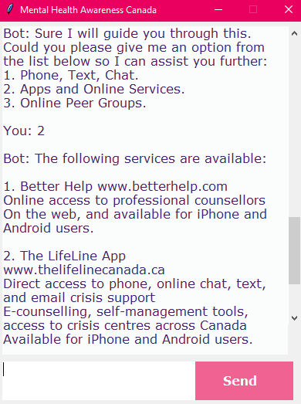
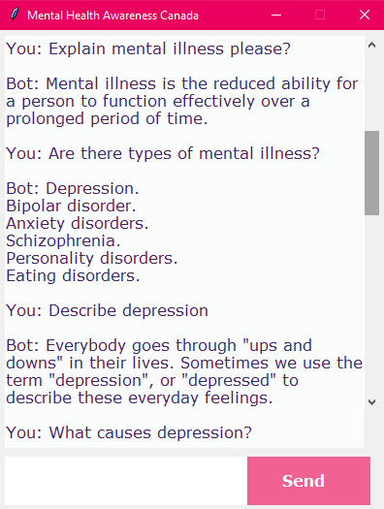
Figure 2. Mental Health Resources aided by the Canadian Government.

.

Figure 1. Chatbot providing information regarding Mental Health Issues.

.

CONCLUSION/IMPLICATION: This research provides insight into developing a Chatbot application to create awareness regarding mental health issues and recommend users to seek help from reliable resources available in Canada. Rather than focusing on self-help therapies, this application encourages users to discuss their concerns without feeling judged. Further research is needed to incorporate more methodologies into the Chatbot for addressing the reluctance of users from contacting mental health support platforms.

