The development of PET radiotracers for imaging Aurora Kinases
Dong Zhao^{1,2}, Jinqiang Hou^{1,2}

¹Department of Chemistry, Lakehead University, ON, Canada
²Thunder Bay Regional Health Research Institute, ON, Canada

BACKGROUND/OBJECTIVES: Cancer is the leading cause of death in Canada. Comprehensive and personalized treatment starts with an accurate diagnosis. Positron emission tomography (PET) imaging is a non-invasive imaging technique that allows receptor density studies, early cancer diagnosis, and in vivo therapy monitoring. Aurora kinases (AKs) play a key role in cell division via mitotic regulation. Both the kinase activity and expression level of AKs are up-regulated in many human cancers including prostate, breast, ovarian cancers, etc. Therefore, the inhibition of AKs has been regarded as a promising approach for the development of novel anticancer agents. To date, 27 classes of inhibitors have been reported to target AKs, though none have passed clinical trials. Current efforts in AK PET imaging and anticancer drug discovery have been limited. Only one radiolabeled inhibitor ([11C]Alisertib) for PET imaging has been synthesized and evaluated as diagnostic imaging probes for cancer characterization. Unfortunately, the tumor-to-background ratios in A431 tumor were low due to the off-target binding to P-glycoprotein. To develop PET imaging tracers for tracking biological pathways associated with AKs and quantifying the receptor density in malignant tumors in vivo, this project aims to design and prepare novel Fluorine-18 radiolabeled AK inhibitors with high binding affinity and selectivity.

METHOD: Tozasertib initially developed by Vertex was selected as our lead due to its highest binding affinity for Aurora-A among all the inhibitors reported and high selectivity to any other kinases in a 55-kinases panel. The compound was optimized guided by structure-based-drug-design method and synthesized. The IC50 will be evaluated by in vitro enzyme assay to compare the binding affinity. Based on the IC50 data, the structure-activity relationships will be summarized. Candidate molecules with highest binding affinity will be radiolabeled with Fluorine-18 and further evaluated using Bio-distribution (BD) and PET imaging studies to demonstrate the ability of imaging AK expression in cancers in the murine models.

RESULTS: From the binding positions we get the conclusion that as a stretching out group, the variation of R2 doesn’t change the binding model, as a group at the back of binding pocket the carbon number in R1 should be lower than 6 (Fig.1 D the binding pose of VX-680 could not be kept). The designed radiolabeled analogues could keep the binding affinity with Aurora-A from VX-680, indicating that the designed analogues potentially have high potency with Aurora-A, therefore it could a good imaging agent for PET. Based on the proposed synthesis route, two compounds without fluorine were synthesized successfully.

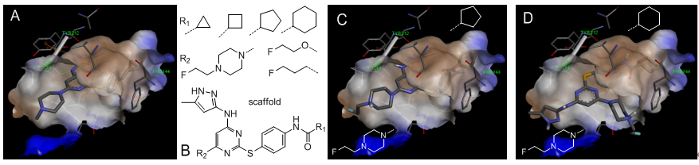
Fig. 1 Binding of VX-680 and designed analogues with Aurora-A. A) The crystal structure of Aurora-A with VX-680; B) First series of VX-680 analogues. C) and D) Binding model of two analogues.

IMPLICATION: The novel radiotracers targeting Aurora kinases could be a promising clinical tool for accurate liver cancer diagnosis. In addition to its utility for detection, this technique will be useful for monitoring disease progression and evaluating efficacy of therapy. Our research also has the potential to provide a powerful tool for quantifying Aurora expression in vivo, and provide a unique understanding of the behavior of Aurora-targeting-drugs and their interactions with the target to assist anti-cancer drug discovery.

