THE DESIGN AND SYNTHESIS OF A PAR2 IMAGING AGENT

Austin Hopkins^{1,2}, Jinqiang Hou^{1,2}

^{1,2}Lakehead University, Department of Chemistry, Ontario, Canada
^{1,2}Thunder Bay Regional Health Research Institute, Ontario, Canada

BACKGROUND/OBJECTIVES: Lung, breast, and liver cancers are some of the most common and deadly forms of cancer in Canada. There are existing methods that can diagnose these diseases, but each has its own flaws. Positron emission tomography imaging is a relatively non-invasive imaging method that allows for the early diagnosis of diseases. It does this by targeting a protein biomarker for the disease within the body with a radioactive molecule called a radiotracer. The synthesis of a novel radiotracer that specifically targets the human PAR2 receptor, a biomarker for these cancers, has been proposed based on a paper published to Nature in 2017. This radiotracer has potential as a diagnostic cancer imaging agent.

METHOD: A seven-step organic synthesis has been proposed for the development of a PAR2-specific radiotracer, shown below in Figure 1.

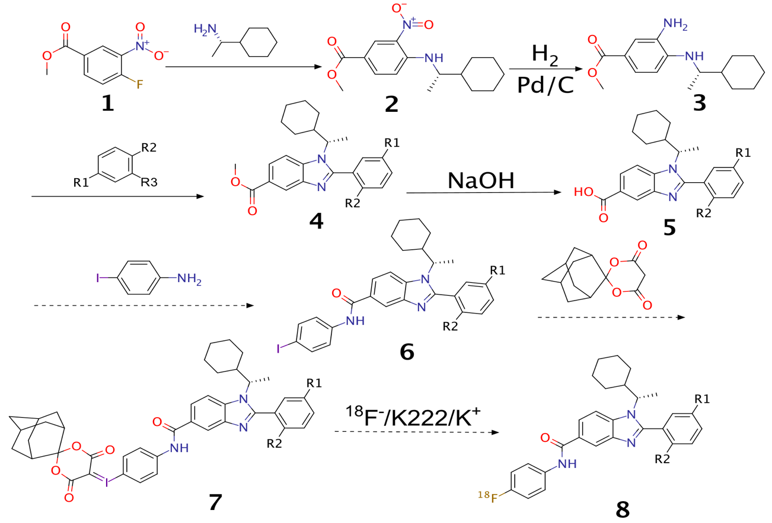
Figure 1. Proposed scheme for the synthesis of a novel PAR2 radiotracer

RESULTS: The first four reaction steps have been attempted thus far. The products of these reactions have been characterized by mass spectrometry, and ¹H NMR spectra have been produced for the products of the first two reactions. 2 and 3 have been confirmed as the desired products, but further purification of 4 and 5 will need to be performed in order for their confirmation.

CONCLUSION/IMPLICATION: Further synthesis will be performed to attain the final radiotracer. If successful, this project has the potential to move on to clinical trials, and eventually, be marketed as a potent and useful tool in the early detection and diagnosis of lung, breast, and prostate cancer.

