Malting effluent for microalgae cultivation and subsequent biomass and lipid production
Janak Raj Khatiwada and Wensheng Qin
Department of Biology, Lakehead University, Thunder Bay, Ontario P7B 5E1, Canada

BACKGROUND/OBJECTIVES: Microalgae can effectively grow in nutrient-rich environment and have ability to accumulate nutrients from wastewater. Malting effluent is rich in nutrients suitable for microalgae cultivation. The aim of this work was to evaluate the growth characteristics and lipid content of two green microalgae grown in the diluted malting effluent.

METHOD: Two green algae Chlorella sp. and Chlamydomonas sp. were isolated from Lake Superior and Lake Tamblyn, Lakehead University, Thunder Bay, Canada and cultivated in 1-L glass flask with a photoperiod of 16 h:8 h light:dark cycle. Total chlorophyll and lipid contents were tested into four dilution concentration of malting effluent: 10%, 30%, 50% and 70% dilution and control condition (BG-11 medium).

RESULTS: A distinct linear increasing trend of chlorophyll content was observed in both Chlorella sp. and Chlamydomonas sp. Chlorella sp. showed highest chlorophyll content in 50% of dilution concentration of malting effluent whereas 70% dilution concentration was most productive for Chlamydomonas sp. The total lipid content was higher in 50% of dilution concentration of malting effluent in both Chlorella sp. (max 20.5%-min 11.5% of dry weight) and Chlamydomonas sp. (max 39.3%-min 25.9% of dry weight).

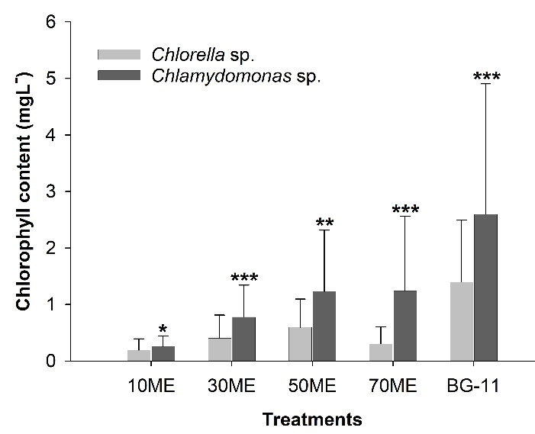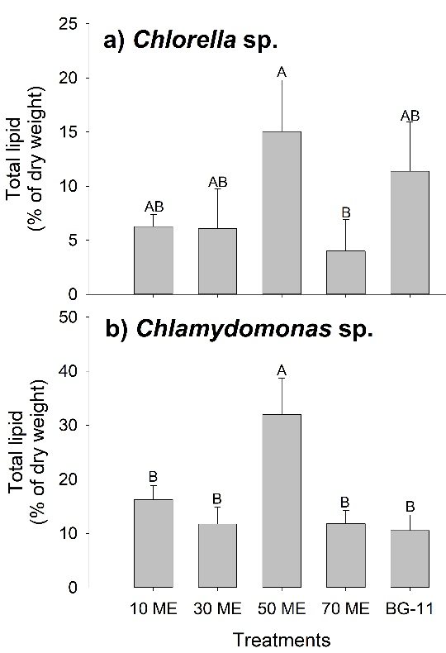

CONCLUSION/IMPLICATION: The results showed that the non-sterile diluted malting effluent is an excellent medium for microalgae cultivation. Microalgae can be used for bioremediation in one hand and production of biofuel and value-added products in other.

