Development of an ¹⁸F Radiolabeling Method using Solid Phase Chemistry

Branden Mandaric

Supervisor: Dr. Michael Campbell
Lakehead University

Background/Objectives: The expansion of clinical applications for positron emission tomography (PET) is dependent on the development of new PET tracers. One challenge in the design/synthesis of a radiotracer is the process of adding the radioactive component. PET tracers must incorporate a radioactive positron emitting isotope, the most popular being ¹⁸F. With a decay half-life of 110 minutes, it is important that ¹⁸F radiolabeling synthesis is done quickly. Our goal is to design a simple and fast method of incorporating ¹⁸F into a molecule.

Method/Preliminary Results: Performing reactions using solid phase reagents has the potential to simplify the synthesis and speed up purification through filtration. This project focuses on using solid phase methods to radiolabel a small molecule and couple this molecule to compounds that need radiolabeling. We are currently developing a method for solid phase fluorination and have already refined a solid phase coupling procedure to work quickly and efficiently in a way that is ideal for hot synthesis.
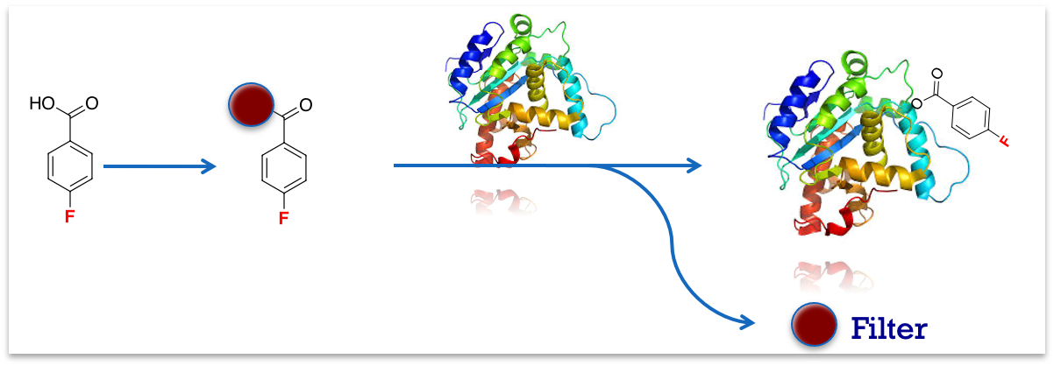
Figure – Using a solid phase coupling procedure the left-over starting material can be filtered, simplifying purification.

