DEVELOPMENT OF SMALL MOLECULE LIGANDS TARGETING THE LYSOPHOSPHATIDIC ACID RECEPTOR 1 FOR PET IMAGING

Jonas E. Olsen¹, Wenjie Liu² , Jinqiang Hou³

^{1,2,3}Lakehead University, Ontario, Canada

BACKGROUND/OBJECTIVES: Lysophosphatidic acid receptors are a class of G protein coupled receptors responsible for a range of signaling functions, typically mediated by lysophosphatidic acid. Lysophosphatidic acid receptor 1 (LPA1) signals various processes such as cell motility, proliferation, and survival, as well as angiogenesis. Due to the significant upregulation of LPA1 in some types of cancer, it has high potential to be a target for positron emission tomography (PET) imaging agents. Using radiolabeled small molecules as imaging agents in PET is a relatively unexplored modality, and it could provide a means of quickly and efficiently imaging tumours with high contrast. Our group is focused on the development of novel small molecule LPA1 ligands to be radiolabeled and tested as imaging agents.

METHOD: Our current approach is to create a small library of analogues based on reported LPA1 antagonists through multi-step organic synthesis. Once a large enough library is created, ligand binding will be assessed in vitro and ligand structure will be optimized. Promising candidates will be radiolabeled and tested in vivo.

RESULTS: As of now we are developing novel ligands; most of our current work is focused on optimizing synthetic pathways and synthesizing more analogues. We have made significant progress in a multistep organic synthesis scheme, and plan on having more data to present by the end of august.
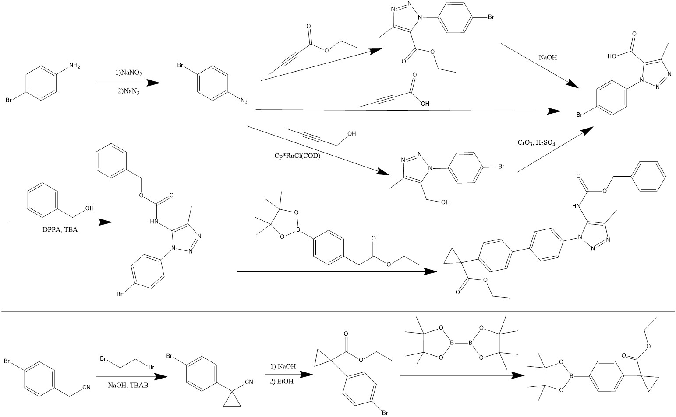

CONCLUSION/IMPLICATION: PET imaging agents developed to image tumours could have significant implications for cancer diagnosis and treatment. PET provides a quick and non-invasive means of taking good resolution images, and designing small molecule ligands could allow for imaging of cancer types inaccessible to other imaging modalities.

SESBASS 2021
Presenting Author Details

Last Name Olsen

First Name Jonas Title Mr.

Email jeolsen@lakeheadu.ca

Institution Lakehead University

Department Chemistry

Mailing Address ___345 N. Norah St, Thunder Bay, ON._____
_____________________________________________________
_____________________________________________________

Preferred Presentation Type
Oral x
Poster

Preferred Topical Session
Environmental Sustainability
Clinical & Health Research x
Digital Health Technologies

